K & K

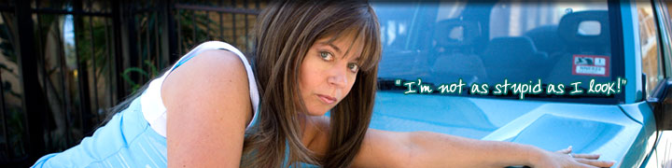





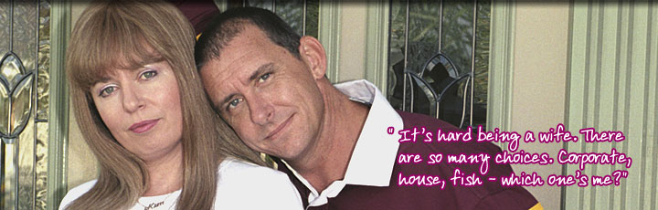









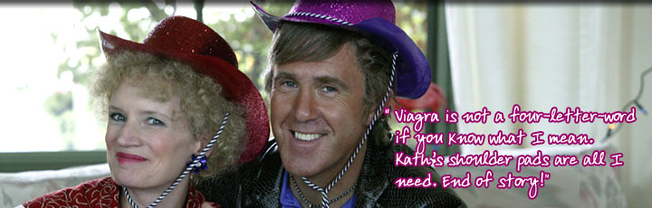


Self-confessed yummy mummy Kim Craig has her hands full with an exceptionally bright Epponnee Rae. She still gets plenty of me-time though and heads to Fountain Gate to window shop at Typpphaneez and drool over all the bling...literally (she is now banned from the shop).

________________________________________

